SUSTAINABLE DEVELOPMENT GOALS AND PAKISTAN

This insight explores Pakistan's implementation of the Sustainable Development Goals (SDGs), a global agenda adopted in 2015 to achieve sustainable development by 2030. Despite initial commitment, Pakistan's ranking has fluctuated, currently standing at 137th in 2024. The analysis highlights Pakistan's moderate improvements in some SDGs and challenges in others, attributing inconsistencies to political instability and economic constraints. Recommendations include enhancing political will, institutional frameworks, data collection, and international collaboration. Achieving the SDGs in Pakistan requires sustained efforts, effective governance, and a coordinated approach across various societal sectors.

July 30, 2024 3 MINUTES READ
 | Written By  Asim Shafique  Intern

Member states of the UN, in pursuit of collective sustainable development, agreed to adopt a set of Sustainable Development Goals (SDGs) in 2015. The destination was to protect the planet, end poverty and ensure prosperity for all by 2030. These SDGs are determined by 17 goals, including 169 associated targets and 232 indicators pursued in synchronised international cooperation efforts and national frameworks. The government is independent in taking charge and creating national frameworks to accomplish SDGs, as they are not legally obligatory. Therefore, the interest of international organisations and the effectiveness with which national governments craft programmes to reap the benefits of international support will determine the success of the SDGs. The accomplishment of the Millennium Development Goals (MDGs) serves as the foundation for the SDGs.
Since January 1, 2016, the Pakistani government has been actively implementing the SDGs. A dedicated section within the Ministry of Planning, Development and Special Initiative is the national coordinating entity for this effort. The government has prioritised the 17 goals into three categories, demonstrating its commitment to achieving the SDGs.
Priority 1: Zero Hunger (SDG 2), Good Health and Well-being (SDG 3), Quality Education (SDG 4), Clean Water and Sanitation (SDG 6), Affordable and Clean Energy (SDG 7), Decent Work and Economic Growth (SDG 8), and Peace, Justice, and Strong Institutions (SDG 16).
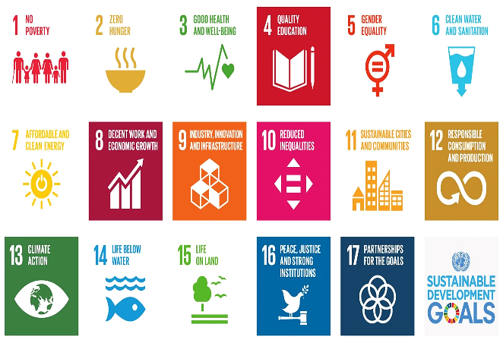

Priority 2: No Poverty (SDG 1), Gender Equality (SDG 5), Industry, Innovation and Infrastructure (SDG 9), Reduce Inequality (SDG 10), Partnership for the Goals (SDG 17), and Sustainable Cities and Communities (SDG 11).
Priority 3: Responsible Consumption and Production (SDG 12), Climate Action (SDG 13), Life Below Water (SDG 14) and Life on Land (SDG 15).
Pakistan was among the first countries to adopt the 2030 SDGs agenda through a unanimous parliament resolution. Unfortunately, its ranking has fluctuated over the years, showing inconsistent implementation strategies. Initially, Pakistan stood at 122 and moved to 134 in 2020, then came back to 128 in 2023 with an overall score of 58.97, and again moved to 137 recently in 2024. In comparison, we can see that even the smaller neighbouring countries like Bhutan, Nepal, Sri Lanka and Bangladesh have a better ranking/score than Pakistan (as shown in Graph).

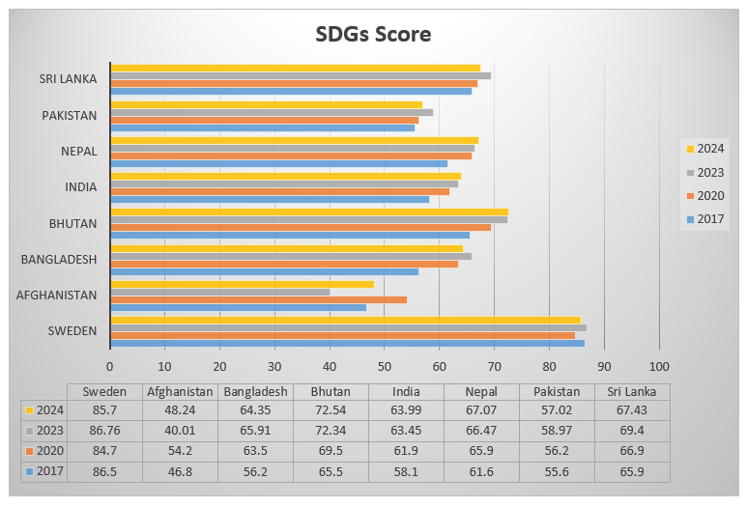
Source: Sustainable Development Report 2017, 2020 and 2024

In a recent sustainable development report 2024, Pakistan's ranking declined to 137th from 128th in (2023) with an overall score of (57.02). The table below shows the detailed performance of Pakistan in 2024 and its comparison with its performance in 2017 and 2020 in achieving the SDGs.
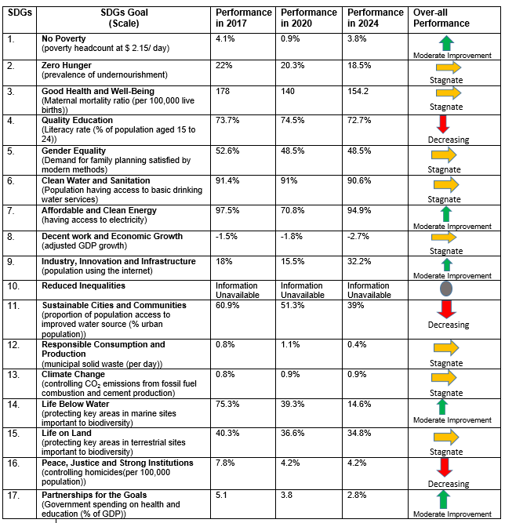
Source: Sustainable Development Report 2017, 2020 and 2024.

The Sustainable Development Report 2024 indicates that Pakistan has shown moderate improvement in SDGs 1, 7, 9, 14 and 17. This progress should instil a sense of hope and optimism in the audience. Similarly, Pakistan has stagnated performance in SDGs 2, 3, 5, 6, 8, 12, and 15. Pakistan faces significant challenges in SDGs 4, 11, and 16. However, in SDG 10, the United Nations hasn’t received any data from Pakistan.
Pakistan needs political will, clear targets, elaborate timelines, budget allocations, robust regulatory framework, and legal support to ensure accountability to achieve the SDGs.
Pakistan's SDGs ranking has fluctuated since 2015. This is because of inconsistent policies, unstable political situation, economic constraints, etc. Achieving the SDGs requires long-term commitment and cooperation from various segments of society. The financial, sociopolitical, and environmental aspects must converge harmoniously to achieve sustainable development. The following are recommended for Pakistan to achieve the SDGs: -
- Pakistan needs political will, clear targets, elaborate timelines, budget allocations, robust regulatory framework, and legal support to ensure accountability to achieve the SDGs.
- Implementing the SDGs in Pakistan requires a robust institutional framework. This involves collaboration between federal and provincial bodies, government agencies, civil society, businesses, and academia. The complexity of this task underscores the need for a coordinated and comprehensive approach to achieving the SDGs.
- To ensure evidence-based decisions, the government must enhance its data collection, analysis and reporting mechanisms.
- Campaigns to raise awareness about the SDGs should be launched nationwide. Similarly, SDGs content should be incorporated into educational curricula to foster a culture of sustainability.
- Pakistan must implement anti-poverty programmes and promote inclusive economic growth to eradicate poverty.
- Collaboration with other nations, active participation in international forums, and partnerships to share SDG implementation knowledge, resources, and technology are crucial.
In summary, Pakistan has made strides in several areas, but social inequality, economic limitations, and political instability prevent the SDGs from being fully achieved. Achieving sustainable development is contingent upon implementing efficient governance, sustained endeavours, and international collaboration.

Disclaimer: The views expressed in this Insight are of the author(s) alone and do not necessarily reflect the policy of NDU.

