Religious Tourism and Its Potential in Pakistan

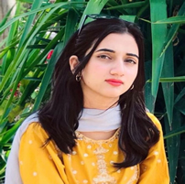

Hadia Ibrar

March 29, 2024

Email: hadiaibrar62@gmail.com

This insight explores Pakistan’s vast potential for religious tourism, showcasing its rich cultural and religious heritage. With diverse sites for Sikhs, Buddhists, Hindus, and Sufis, Pakistan can attract global visitors. However, challenges like infrastructure and visa policies need addressing. To maximize this potential, Pakistan needs a comprehensive tourism policy and stronger public-private collaboration.

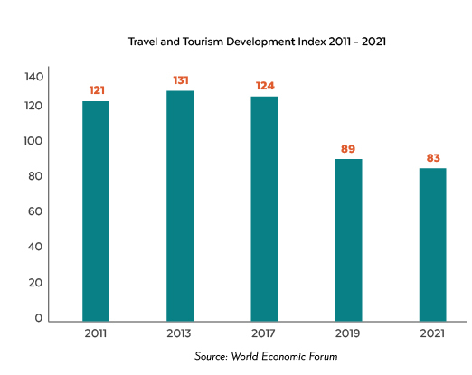
Regional tourism is a significant global industry, with massive potential for visitors to holy sites and places of religious importance on different occasions. Pakistan, a diverse society, hosts a rich cultural and religious heritage of religions like Islam, Hinduism, Sikhism, Buddhism, and Christianity. After independence in 1947, the Hindus and Sikhs left their sacred places behind, presenting significant untapped potential in religious tourism. According to the Pakistan Tourism Development Corporation (PTDC), there are 480 tourist destinations in the country, 120 of which are religious sites. Pakistan is currently ranked in "Category-C" in the international travel rankings for tourism. Pakistan's ranking on the International Travel and Tourism Development Index has risen from 89th in 2019 to 83rd in 2021, making it the Asia Pacific Region's most improved country since 2019.
Pakistan is home to 80% of the Sikh religion's most sacred sites, including Nankana Sahib, the birthplace of Guru Nanak Dev. The country hosts 195 Gurdwaras, with the five most significant being Kartarpur Sahib, Gurdwara Panja Sahib Hasan Abdal, Gurdwara Dera Sahib Lahore, Nankana Sahib, and Samadhi of Ranjit Singh Lahore. Each year, approximately 7,500 Sikhs from India and 2,000 from across the world make the journey to Pakistan, a testament to the accessibility and convenience of these religious sites.
Pakistan is actively preserving and restoring sites for the Sikh pilgrimage, including the Kartarpur Corridor, a testament to the country's commitment to religious tourism. This corridor has not only eased border crossings but also provided visa-free services, further enhancing the accessibility of these sites. With over 83% of Pakistan's 26 million Sikh population expressing interest in religious pilgrimages, the tourism potential is immense, with an estimated 44,000 annual tourists and a projected revenue of Rs. 18 billion.
The Gandhara region of Pakistan, including Mardan, Taxila, and Swat, is a popular destination for Buddhist tourists due to its rich heritage of Stupas of Gautam Buddha.
Pakistan's most visited and holiest Buddhist places include the Dharma Rajika Stupa, Sleeping Buddha, Takht-i-Bai, and Stupa of Mankiala. The country's Buddhist heritage sites attract tourists from Japan, Korea, Hong Kong, China, and Sri Lanka. Takht-i-Bai, a small town near Islamabad, is the most visited site by Buddhists. According to the Ministry of Foreign Affairs, Pakistan attracts approximately 2000 Buddhist monks annually for religious tourism. The global Buddhist tourism market, involving 500 million Buddhists, could contribute Rs. 16 billion to Pakistan's GDP and create employment opportunities for 30,772 individuals.
Hindus are 1.6% of Pakistan’s population and the largest minority group. Major Hindu temples in Pakistan include the Shri Hinglaj Mata Temple in Baluchistan, the Shiv Mandir in Umarkot, the Katas Raj Temple Complex in Chakwal, and the Shri Panchmukhi Hanuman Mandir in Karachi. In 2022, the Pakistani High Commission granted over 400 visas to Indian Hindus to visit Pakistan's historic Hindu shrines under the 1974 Pakistan-India Protocol on Visits to Religious Shrines.
The Chitral region in Khyber Pakhtunkhwa (KP) is home to a diverse population of Kalash, descendants of ancient Dardic people. With around 3,000 members, they practice an animistic religion originating from Hinduism and pre-Islamic Nuristan beliefs. The Kalash community celebrates festivals like Chilam Joshi, Uchal, and Chawmos, attracting over 2.5 million domestic and 1000 foreign visitors to its cultural and historical events.
Pakistan is renowned for its Sufi culture, which significantly contributed to the spread of Islam throughout the Indian subcontinent. Pakistan possesses several shrines dedicated to religious figures, including Hazrat Data Ganj Bakhsh, Hazrat Baba Farid Ganj Shakar, Baba Bhullay Shah, Hazrat Shah Rukn-e-Alam, and Hazrat Lal Shahbaz Qalandar. Millions of individuals set out on spiritual pilgrimages to the shrines every year.
The government of Pakistan manages religious sites, including their conservation and custody. The Evacuee Trust Property Board (ETPB) manages the properties and land left over by Sikhs and Hindus. PTDC, owned by the government, operates motels and promotes tourism. The National Tourism Coordination Board (NTCB) was established to develop strategic guidelines and policies for the growth of the tourism sector, with PTDC as its implementation body. The private sector manages services like hotels, restaurants, travel agencies, and tour operators. The tourism sector has been devolved into provincial subject under the 18th constitutional amendment, but the federal government still manages international conventions and agreements. The Auqaf and Religious Affairs department manages Shrines, Dargahs, and Mosques, ensuring proper facilities and cleanliness for religious activities.
Religious tourism in Pakistan is a growing sector with significant economic potential, fostering job creation, infrastructure development, and enhanced connectivity. The World Travel and Tourism Council predict that Sikh tourism can contribute Rs. 18 billion annually to Pakistan's economy, creating 82,000 jobs. Moreover, domestic visits to revered sites like Gurdwaras of Nankana Sahib and Buddhist archaeological sites could potentially contribute over Rs. 16 billion to GDP and employment for 30,772 people in Pakistan.
Pakistan's tourism sector has improved significantly over the years. Successive governments have focused on reviving it through a national task force and a new visa policy. PTDC has developed a five-year plan for 2024-2029 to enhance the sector by boosting employment, growth, investment, international tourism, domestic tourism, and Sikh and Buddhist religious tourism, thereby increasing revenues.
Despite some efforts, the sector faces several issues. Pakistan lacks a comprehensive national tourism policy because of a lack of coordination between federal and provincial governments in legislation and strategies. There are also no accurate statistics on religious tourism. Additionally, sacred Hindu temples and other religious sites face neglect and poor preservation, and the geopolitical environment and poor air connectivity make it difficult for Sikhs and Buddhists to obtain Pakistani visas. Additionally, the stringent land lease policy for tourism projects, security, and poor infrastructure hinder progress.
There is a need to formulate a comprehensive National Tourism Policy to pave the way forward in unlocking the country's untapped potential in religious tourism and generating substantial financial revenue. Pakistan should improve its World Tourism Index ranking from 83rd to a position within the top 70 and from Category “C” to “B” within the next five years. Pakistan should aim to develop its religious tourism sector, generating approximately US$ 500 million in revenue and 15,000 jobs annually, to surpass US$ 2-3 billion and create over 70,000 jobs in the next five years.
Pakistan should establish a clear supervisory structure and update laws to involve the private sector in tourism development. The government should focus on facilitation and regulation, attracting private investment for sustainable growth. The government should ensure proper management and preservation of religious sites through public-private partnerships, while the private sector should focus on improving service standards in hotels and restaurants. Modern technologies like virtual reality can enhance the tourist experience and appeal to domestic and foreign travellers.

Disclaimer: The views expressed in this Insight are of the author(s) alone and do not necessarily reflect the policy of NDU.

