PAKISTAN’S CIVIL DEFENCE: NEED FOR MODERNISATION AND INTEGRATION
Pakistan’s Civil Defence: Need for Modernisation and Integration

The Civil Defence Department (CDD) in Pakistan, established under the 1952 Civil Defence Act, plays a vital role in safeguarding citizens and coordinating emergency responses. Despite its historical significance, such as contributions during the 1965 and 1971 wars, the CDD faces challenges due to outdated methods, limited funding, and a lack of modern technology. This insight highlights the department's structure, its evolution, and the urgent need for modernization. Recommendations include integrating advanced training tools, revising funding allocation systems, and reintroducing community and educational initiatives to enhance civil defence capabilities and ensure national safety.

November 05, 2024 3 MINUTES READ
 | Written By  Asfa Azam  Intern  Email: asfaazam2000@gmail.com
The Civil Defence Department (CDD), formed under the Civil Defence Act of Pakistan in 1952, is crucial in protecting citizens, mitigating disaster impacts, and coordinating emergency responses. Historically, CDD has been instrumental in protecting lives, training civilians in camouflage, and fostering national solidarity during the 1965 and 1971 Wars. However, despite its historical significance, the department has struggled to evolve, relying on outdated methods. This insight explores the challenges of CDD and underscores the urgent need for its modernisation and improved funding.
CDD has been a member of the International Civil Defence Organization (ICDO) since January 1970, further solidifying its role in national safety. The ICDO is a global body that promotes and coordinates international cooperation in civil protection. Federal CDD continues to act as a liaison for the ICDO in Pakistan. The foundation of civil defence dates back to the pre-independence era when activities like protecting civilians were carried out under the Air Raid Precaution (ARP) during World War II.
The mandate of CDD is to coordinate passive defence policy and implement civil defence measures during peacetime and wartime. The department assists the armed forces during war or emergencies by establishing a communication link between the armed forces and the public, thereby enhancing the efficacy of defensive measures. The primary objectives of CDD are to minimise civilian casualties, protect essential services, and ensure continuous civilian support to war efforts.
Figure - 1: CDD Organogram at Federal Level
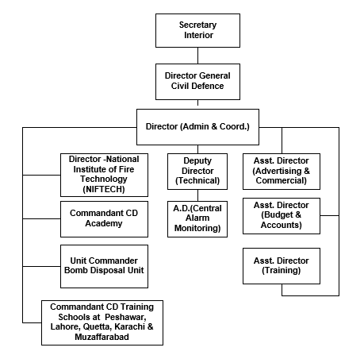

Source: Directorate General of Civil Defence
The general public also participates voluntarily and disciplinedly in civil defence training for war and peacetime. To further strengthen the efforts, CDD raises awareness among students in schools, colleges, and other institutions regarding civil defence.
The department was devolved to provinces after the 18th Amendment in 2010. Today, it operates at the Federal, Provincial, and District Levels. The Federal Directorate of Civil Defence operates under the Ministry of Interior (MoI) and has 300 employees and ten training institutions all over Pakistan. These institutions offer free courses to government officials, autonomous bodies, and the general public, which should promote a safe culture in Pakistan. The Federal CDD is also responsible for training facilities across Pakistan for public and private sector organisations and offering fire and life safety consultancy services.
To revitalise the Civil Defence Department, streamlining its mandate, improving training programs and integrating modern technologies are essential for improved efficiency and effectiveness.
The provinces and Azad Jammu Kashmir (AJK) have their regional directorates. The Provincial CDD offices function under their respective home ministries, with offices in provincial capitals, e.g., Lahore, Karachi, Peshawar, Quetta and Muzaffarabad. District Coordination Officers (DCOs) serve as Controllers of Civil Defence at the district level. CDD offices are established in 36 of 42 districts in Punjab, 35 of 38 districts in KPK, 7 of 37 districts in Balochistan, 21 of 30 districts in Sindh, 10 of 14 districts in Gilgit Baltistan, and all ten districts of AJK. This decentralised structure enables swift responses, but the capacity varies according to the district.
Figure - 2: CDD Organogram at Provincial and District Levels
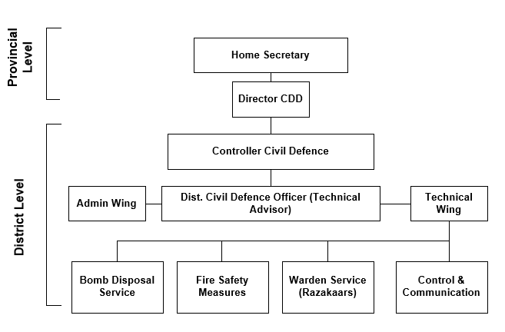

Source: Civil Defence Department
The provincial and district offices provide essential training, such as Bomb Disposal (BD), First Aid, and Firefighting. In addition, they oversee volunteer activities during emergencies, inspect fire safety measures, provide explosive ordinance disposal services, and maintain communication with the public during wartime.
Each district office consists of a BD unit, training staff (who deliver training within CDD offices and educational institutions), and inspection staff (who ensure fire safety compliance in buildings and industries). The general structure and services of district CDD offices, as shown in Figure 2, may vary based on local requirements. Moreover, CDD security personnel and volunteers also assist with security duties during processions in Muharram and Rabi-ul-Awwal.
In an interview, Ijaz Mahmood Malik, former DG Federal CDD, said that, following the 2014 Army Public School Peshawar attack, around 4,000 teachers and students were trained in civil defence within three months. This means that CDD has the capacity for large-scale training initiatives. However, various challenges, such as limited funding, outdated technology, and the need for better coordination with other agencies, hinder its effectiveness.
Table 1 outlines the courses and training conducted by the Federal CDD training institutes in 2023 and 2024. The data indicates a positive trend, with the total number of trained individuals (government officers, industrial staff, students, and the public) in the first six months of 2024 already exceeding half of the total trained in 2023. This upward trend suggests that the number will likely surpass the previous year's total by the end of 2024, demonstrating progress and encouraging further efforts in civil defence training.
Tabele -1: Civil Defence Training Summary 2023-June 2024
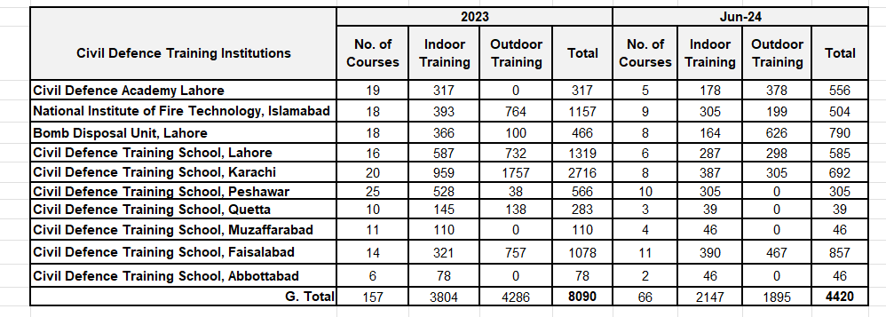

Source: Directorate General of Civil Defence
Despite its crucial role in national safety, the Federal CDD faces a pressing issue of limited funding. With an approximately 400 million PKR allocation for FY24-25, the department is significantly underfunded compared to other government agencies. This financial constraint and improper fund utilisation hamper the department's modernisation efforts. The provincial directorates face a similar financial situation. From the total budget given to the provincial CDDs, only a small portion, about 1%, is distributed to each district. This uniform approach to resource distribution fails to account for varying local needs. Adopting a need-based budget allocation system, where districts can prioritise their needs and use funds effectively, is necessary to address this. For transparency, regular performance assessments and financial audits are also required.
While the department continues to offer training, it remains technologically outdated, especially in an era when modern civil defence operations increasingly rely on advanced technologies. For instance, global firefighting techniques have integrated drones and other advanced tools, whereas CDD still relies on traditional methods. Therefore, combining advanced training equipment would elevate the quality and capacity of training.
Furthermore, CDD operates before, during, and after disasters, either natural or manmade, coordinating with other agencies in efforts during and after disasters. However, 60% of Pakistan’s population lives in rural areas, where CDD has limited reach. It is crucial to involve these communities in civil defence efforts. By implementing community-based training programmes and establishing volunteer civil defence corps in rural districts, we can address unique local risks and make the communities feel more involved and responsible for their safety. This inclusive approach will not only enhance the effectiveness of civil defence but also make the communities feel integral to the overall safety strategy.
To enhance its outcome, CDD should revise and reinforce its wartime mandate by collaborating with the Ministry of Education to reintroduce the National Cadet Corps (NCC) and Pakistan Women National Guards (PWNG) training within schools, colleges, and universities. While NCC and PWNG have been discontinued, reintroducing similar training programmes can benefit the department in setting up an auxiliary force to assist forces during wars.
Therefore, CDD, a crucial national safety department, holds a promising future. Despite the challenges, there is a significant potential for improvement. We can significantly enhance the department's performance and civil defence capabilities by addressing financial inefficiencies, adopting a need-based budget allocation system, modernising training, and revising CDD’s mandate. This will ensure a safer and more resilient future for our nation.
Disclaimer: The views expressed in this Insight are of the author(s) alone and do not necessarily reflect the policy of NDU.

Highlighted text: This insight explores the Civil Defence Department (CDD) of Pakistan, its historical significance, current operations, and challenges faced in modernization. Established under the Civil Defence Act of 1952, the CDD plays a key role in disaster response, public safety, and coordination with armed forces during wartime. While the CDD has been effective in past training initiatives and public awareness efforts, it suffers from budget constraints and outdated technologies, which impact its efficiency and outreach, particularly in rural areas. The insight discusses the need for a targeted budget allocation to meet specific district needs and highlights the potential benefits of reinstating community and institutional training programs, to foster a more prepared and resilient population. Addressing these issues, along with integrating modern technology and refining CDD’s structure, would greatly enhance the department's capacity to safeguard and serve the nation.

