PAKISTAN AMIDST US-CHINA CHIP COMPETITION: NAVIGATING TECHNOLOGICAL OPPORTUNITIES

This INSIGHT explores Pakistan's opportunities and challenges in the context of the US-China semiconductor rivalry. It discusses Pakistan's potential to become a key player in the chip industry due to its strategic location and cost-effective labour force. The analysis strongly emphasises the urgency of developing chip design and testing capabilities in Pakistan, fostering international collaborations, and implementing a strategic approach to capitalise on the growing global semiconductor market.

June 3, 2024 3 MINUTES READ
 | Written By  Haadia Riaz  Intern

The 21st century has witnessed a shift in dominance from oil to microchips. Today, political, economic, and military power is intricately tied to these semiconductors. Mastery over semiconductor Global Value Chains (GVCs) has become a bone of contention between the United States (US) and China in technological competition. This US-China chip rivalry, which can become a blessing in disguise for Pakistan, presents significant opportunities for the country. Pakistan's strategic location and leverage of cheap labour position it as a key player within the chip industry, particularly in collaboration with these global leaders. This underscores the potential benefits for Pakistan in the US-China chip rivalry, making the audience feel the importance of this situation.
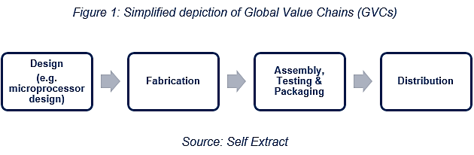

Chips are produced through GVCs, and the stages of the production process are spread among firms in different states. The supply chain begins with “fabless” chip makers in the US, who design the architecture of chips using Electronic Design Automation software. These companies focus on chip design and innovation and outsource manufacturing to “foundries” in Taiwan, South Korea, and Japan. Foundries are specialised manufacturing facilities that produce chips on behalf of fabless companies, using advanced fabrication processes and equipment.
Though fabrication remains a challenge, Pakistan’s emphasis on chip design, testing, and packaging, coupled with its lower labour cost, offers promising technological prospects for Pakistan amidst the US-China chip competition.
The Chinese semiconductor industry still lags far behind the other global chip competitors. According to Chris Miller in his book Chip War: The Fight for the World's Most Critical Technology, China spends more money importing microchips than oil. We design 95% of the chips that China uses. Hence, it has been identified as a significant vulnerability of China's long-term ambitions. Amidst this context, President Xi launched an inward-looking state capitalism strategy prioritising Chinese firms over foreign firms to achieve self-sufficiency under the “Made in China 2025” plan and the 14th five-year plan for "technology independence".
The US has intensified its competition with China in the chip industry by signing the “CHIPS and Science Act of 2022,” a comprehensive legislation to boost domestic chip production and research. The act includes provisions for a US$52.7 billion investment over five years to revitalise semiconductor production in the US, thereby reducing its dependence on foreign chip manufacturers. This is a significant move that can reshape the global chip industry and directly affect the US-China chip rivalry. Furthermore, the US Department of Commerce issued new export controls to prevent China from accessing chips made with US equipment, areas where US technology is critical and irreplaceable, to slow down China's military and technological advances. It is irreplaceable to slow down China’s military and technological advances. This competition was further intensified when Biden broadened the scope from bilateral to multilateral by proposing the “Chip-4 Alliance” to integrate the chip-related policies among chip-producing states against China. Beijing retaliated by banning the export of crucial rare elements for manufacturing chips, namely germanium and gallium. China produces 60% of the world's germanium and 98% of the world's gallium.
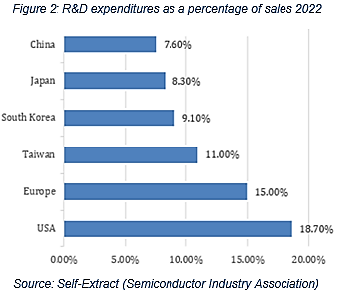

While the US and China are pouring billions into achieving self-reliance in the chip industry, the looming challenge of insufficient skilled labour is projected to be a significant hurdle in the coming years. The Semiconductor Industry Association anticipates that the US is expected to witness a growth in the semiconductor workforce from 345,000 jobs to an estimated 460,000 by 2030, marking a 30% increase. However, 58% of these expected new positions are at risk of remaining unfilled with the current degree completion rates. Similarly, the China Center for Information Industry Development think tank and the China Semiconductor Industry Association jointly published a white paper that projected a work deficit of 200,000 professionals in the chip industry. This is a particularly pressing challenge given Pakistan's nascent stage in the semiconductor space.

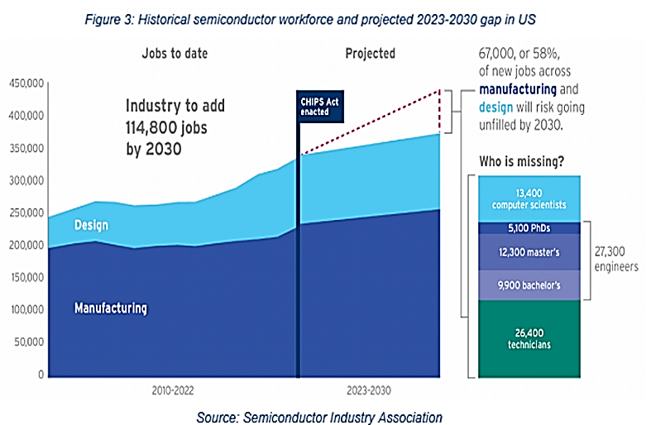

With its abundant, low-cost labour and strategic location, Pakistan holds immense potential to emerge as a critical player in the chip industry. Drawing parallels, it's crucial to note that South Korea’s ascent as a chip-producing state was mainly due to its low-cost and skilled labour, which played a pivotal role in its chip industry. This raises whether Pakistan possesses skilled labour in the chip sector.
Despite being in its early stages, Pakistan's chip sector boasts a surplus of human capital. With 25,000 engineers graduating annually, Pakistan has a significant pool of potential talent. With the proper training and support, these engineers can become integral contributors to US and Chinese firms, filling the critical workforce void. This underscores the untapped potential of Pakistan's human resources in the chip industry, instilling a sense of optimism about Pakistan's future in this sector.
Pakistan has a minimal history in the chip industry due to its capital-intensive nature. Establishing a state-of-the-art semiconductor fabrication facility necessitates significant investment, ranging from US$2-20 billion - typically taking 6-8 years per industry estimates to achieve profitability. Therefore, the financial investment required at the fabrication stage is a formidable challenge for Pakistan. Additionally, the industry is highly competitive and rapidly evolving, which poses a risk for new entrants. However, with the right strategic approach and support, these challenges can be overcome, and Pakistan can establish itself in the chip industry. It's important to note that the risk of technological obsolescence and the need for continuous innovation are significant challenges that Pakistan must address. This underscores the need for strategic collaboration with global chip leaders, which can enhance Pakistan's credibility and competitiveness in the chip industry and bring in advanced technology, expertise, and market access.
Chip design requires software development and engineering proficiency, which could be more financially viable. In this context, emphasising chip design with outsourcing manufacturing would prove beneficial in the long run.
Although Pakistan does have a few companies that design chips (Table 01). The support of expat-led initiatives, such as Aql-Tech Solutions, which closely collaborates with a leading-edge RISC-V-based processor core IP provider company in the US, is significant in igniting progress. Pakistan needs to enhance such efforts by leveraging the expertise of expats to provide training and facilitate business development within the country. Pakistan's chip industry accounts for less than 1% of the global market, indicating significant room for growth.
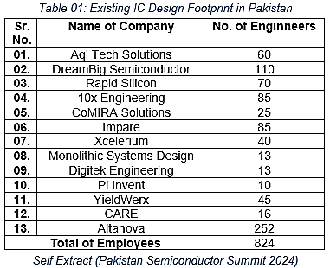

Utilising the triple helix model, the Special Technology Zones Authority (STZA) is instrumental in fostering a conducive ecosystem for the chip industry, promoting collaboration among academia, industry, and government. Additionally, STZA, leveraging government-to-government partnerships, is collaborating with China to devise a multi-pronged strategy for chip design services.
Furthermore, through the Special Investment Facilitation Council (SIFC), Pakistan needs to incentivise foreign firms, particularly from China, to establish chip design centres. China's move to replace Western chips with its own RISC-V architecture presents an opportunity for Pakistan, akin to India's role in Y2K, that wouldn’t require much physical facility but skilled human resources.
Beyond chip design services, Captain (Retd.) Muhammad Mahmood, Additional Secretary of the IT and Telecommunication Division, said that considering Pakistan's economic constraints and limited trained engineers, an incremental approach, beginning with testing and packaging could be more viable.
Recognising that no single country can independently perform all roles in the semiconductor GVCs, China would need to collaborate with friendly nations to achieve competitiveness. Pakistan stands as a promising potential partner. During PM Imran Khan's official visit to China, productive meetings with China's leading technological companies were held. By leveraging Pakistan's low-cost workforce, China could focus on higher-value segments of GVCs, underscoring the strategic importance of this collaboration.
In conclusion, to capitalise on the US-China chip competition, Pakistan needs to amplify its efforts in workforce training and specialised programmes, support entrepreneurship and startups, and, most importantly, collaborate with global chip leaders. This strategic collaboration enhances Pakistan's credibility in the chip industry and opens doors to advanced technologies and international markets. The global chip market is projected to grow from $600 billion in 2023 to over $1 trillion by 2030 – Pakistan should aim to secure approximately $5 billion by 2030.

Disclaimer: The views expressed in this Insight are of the author(s) alone and do not necessarily reflect the policy of NDU.

