Future of Regional Energy Integration: Pakistan’s Perspective

Mr.Taimur Hussain

March 6, 2024

Email: taimur_hussain@hotmail.com

This INSIGHT analyses prospects of Regional Energy Integration (REI) specifically from Pakistan’s perspective, emphasising electricity requirements because South Asia lacks fossil fuel resources. It explores the correlation between energy consumption and growth, climate change and the need for Renewable Energy (RE), existing REI initiatives and their analysis and finally, options for Pakistan.

Eight countries of South Asia (SA) together cover 4% of the world’s land area and 24% of the world’s population. If SA is viewed as a single entity, it is the fifth-largest economy in terms of Gross Domestic Product (GDP). However, in terms of trade and connectivity, it is the least integrated compared to other regional groupings. In Regional Energy Integration (REI), the situation does not fare any better, especially for Pakistan.

Pakistan’s energy sector remains a significant hindrance to industrial development and growth. With a generation capacity of 39,772 megawatts (MW), Pakistan is grappling with an annual shortfall of over 5000 MW. The following data explains the energy-growth linkage by comparing it with other SA countries. There is a general correlation between per capita energy consumption and growth. Pakistan lags behind the SA average in both categories.
Graph-1: Energy and Economy Linkage
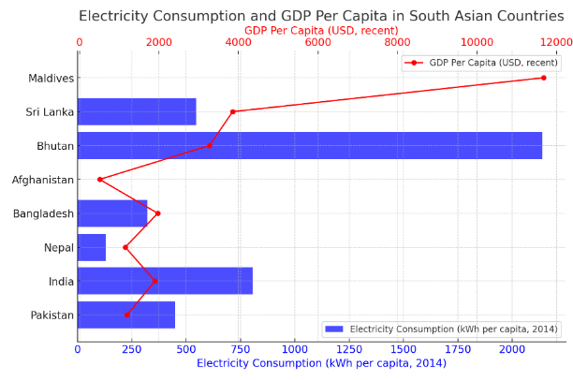

Graph-2: Graph Representing Loss inValue (% of Sales) due to Electric Outages

The trend towards heavily relying on imported fossil fuels for energy generation across South Asian countries, apart from Bangladesh, underscores a significant economic and environmental challenge. This reliance is particularly pronounced in Pakistan, where 65% of energy production is based on fossil fuels. The potential of REI in this context is enormous, offering a structure to significantly reduce the financial drain associated with such imports, evidenced by the substantial proportion of merchandise imports dedicated to fuel, as depicted in Graph 3.
Graph-3: Fuel Imports as % of MerchandiseImports

SA is the region most affected by climate change, with five countries ranking among the top 25 out of 180 in the risk index. This reflects a dire need to shift to greener energy solutions. Pakistan is 8th on the list.

In line with the United Nations (UN) Sustainable Development Goal-7 (SDG-7) of affordable and clean energy, all SA countries have great potential for REI. Despite having one of the world's highest insolation / solar irradiance, Pakistan has produced only 568 MW in 13 years (2010-23).

Table 1: Electricity Generation Capacity of SA Countries
Generation Capacity
Country | Wind (MW) | Utility-scale solar (MW) | Hydropower (MW)
Afghanistan | 67000 | 220000 | 23000
Bangladesh | - | - | 4000
Bhutan | 4825 | - | 263000
India | 102778 | 750000 | 150000
Maldives | - | - | -
Nepal | 3000 | - | 733000
Pakistan | 131800 | 169000 | 60000
Sri Lanka | 24000 | - | 21000
Total | 333403 | 1139000 | 1254000

The existing Cross-Border Electricity Trade (CBET) is depicted in the following graph. There are six REI initiatives from which Pakistan can benefit. A brief overview of the initiatives and their analysis is as follows: -

In 2004, the South Asian Association for Regional Cooperation (SAARC) Energy Centre was established to foster sub-regional cooperation. India’s role was crucial in framing the SAARC Framework Agreement for Energy Cooperation (Electricity) 2014. This framework was designed to boost regional energy collaboration. However, the effectiveness of SAARC initiatives has been debated recently. Notwithstanding these challenges, progress has been reported in cross-border electricity trade among Bangladesh, Nepal, and India, per the World Bank’s findings. Nonetheless, these developments should be considered within the broader context of SAARC dynamics.

Both the Turkmenistan-Afghanistan-Pakistan-India Pipeline (TAPI) and Iran-Pakistan-India (IPI) projects were conceived to acquire cheap gas by accessing Iran and Central Asia (CA). However, both projects still need to be completed. Indian intransigence against Pakistan and undermining of SAARC in favour of other regional platforms like the Bay of Bengal Initiative for Multisectoral Technical and Economic Cooperation (BIMSTEC) and Bangladesh, Bhutan, India, Nepal (BBIN) skirting Pakistan leaves little hope for REI from the East.

Instability in Afghanistan hinders the transit of energy from Central Asia to Pakistan. Nevertheless, there lies an opportunity within Afghanistan itself. The country imports 85% of its electricity from four to five neighbouring countries, excluding Pakistan. Since Afghanistan has no unified, country-wide transmission system, its population centres along the border with Pakistan present a unique opportunity for energy trade. Notably, Pakistan's electricity demand in winter is about 35% lower than in summer. In contrast, Afghanistan's winter electricity needs surge to 150 - 180% of its summer consumption.
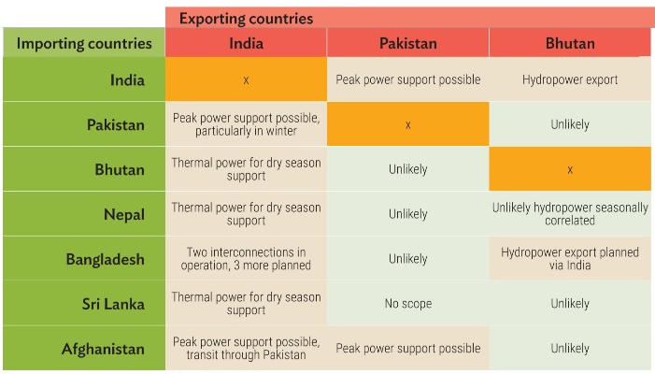
Table 1: REI / CBET Potential of SA

Figure 2: Mapping Afghanistan’s Electricity Grid System
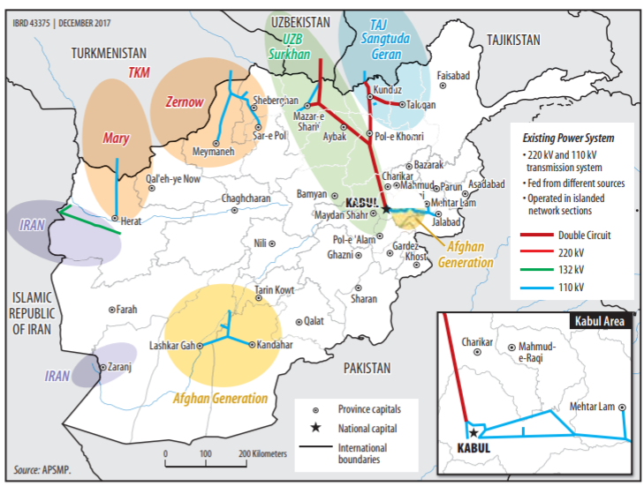

The recommendations emphasise a strategic shift in REI for Pakistan, moving the focus from the East to the West, particularly towards the Central Asia-South Asia–1000 (CASA-1000) project and Afghanistan. This shift is in response to the current geopolitical climate, where collaboration with India appears unlikely.

Pakistan should continue engaging with the South Asia Regional Initiative for Energy Integration (SARI/EI), SAARC, and ESCAP to explore fair and reliable CBET options. The emphasis should be on fostering connections with Central Asia through the CASA-1000 project, which aims to facilitate electricity trade from Tajikistan and Kyrgyzstan to Pakistan and Afghanistan.

It is recommended that the Ministry of Foreign Affairs (MoFA) and the Ministry of Energy (MoE) work with the World Bank to release funds essential for CASA-1000 and engage with the Government of the Islamic Emirate of Afghanistan (IEA) to facilitate the development of transmission lines.

A vital aspect of these recommendations is to utilise Pakistan’s reduced winter electricity demand by supplying surplus energy to Afghan provinces that experience a spike in demand during the colder months. This approach not only aids Afghanistan but also strengthens Pakistan’s role in regional energy dynamics.

MoFA is also advised to diplomatically engage with Muslim countries and the United Nations to raise awareness about the challenges of electricity scarcity during winter in the region and to secure funding and support for developing transmission infrastructure and CBET.

The recommendations urge the reinvigoration of the MoE (Power Division) and the China-Pakistan Economic Corridor (CPEC) Authority to expedite the completion of ongoing CPEC energy projects. This includes improving the accountability and efficiency systems within MoE (Power Division) and the Alternative Energy Development Board (AEDB), with a six-monthly review mechanism overseen by the National Security Division / Prime Minister’s Secretariat, and penalties for inefficiencies.

Lastly, the MoE may be urged to prioritise clean Renewable Energy (RE) initiatives and seek funding and assistance from international bodies like the Green Climate Fund, established under the United Nations Framework Convention on Climate Change (COP-17). This approach aims to enhance Pakistan’s energy security and contribute to global efforts to combat climate change.

A comprehensive and forward-looking strategy is imperative to harness the potential of REI and enhance Pakistan's energy security. This strategy should prioritise diversifying energy sources, expanding CBET, and fostering collaboration with neighbouring countries. Pakistan can significantly bolster its energy independence by focusing on renewable energy and leveraging regional partnerships, contributing to sustainable economic growth and national security. This strategic direction is vital for Pakistan's energy sector and its broader socio-economic development and resilience in the face of global energy challenges.

Disclaimer: The views expressed in this Insight are of the author(s) alone and do not necessarily reflect the policy of NDU.

