BUDDHIST HERITAGE OF PAKISTAN: A BRIDGE TO PEACE AND HARMONY

The Buddhist heritage of Pakistan is a testament to its rich and diverse historical legacy, with significant archaeological sites spread across the Gandhara region, including Taxila and Swat. These sites not only highlight Pakistan's cultural ties to Buddhism but also offer immense potential for promoting peace and harmony with Buddhist-majority nations. Leveraging this heritage through enhanced preservation, marketing strategies, and infrastructure development can transform Pakistan into a leading destination for religious tourism, fostering economic growth and cross-cultural connections.

December 11, 2024 3 MINUTES READ
 | Written By  Abdur Rehman  Intern  Email: muhammadar3488@gmail.com
Pakistan, predominantly a Muslim country, has a rich history and heritage of many other religions, such as Hinduism, Sikhism, and Buddhism. Among these religions, Buddhism left a rich archaeological and civilisational heritage. Buddha was born in present-day southern Nepal. He travelled through the subcontinent and visited present-day Pakistan during his meditation journey. Consequently, Buddhism flourished in present-day Pakistan, spanning over a millennium. This period left a rich heritage in Pakistan, including philosophy, art, culture, architecture and stupas. This heritage spreads from northern Pakistan to southern Afghanistan. This insight explores how Pakistan's Buddhist heritage can bridge peace and harmony between Pakistan and Buddhist nations.
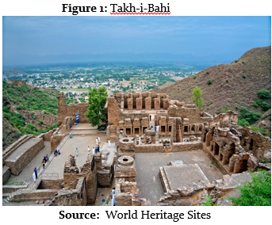

Buddhism thrived in the Gandhara region, which now encompasses modern-day Peshawar, Swat, and Taxila, from the 2nd century BC to the 8th century AD. This era saw the birth of a remarkable cultural legacy, evident in its architecture and a unique blend of Buddhist and Greek elements. The ruins of Takht-i-Bahi in Swat, dating back to the 1st century (Figure 1), and the Buddhist statues at the Lahore Fort, which contains Buddhist carvings and inscriptions, are a testament to this fascinating blend. The archaeological sites at Taxila further enrich this cultural tapestry.
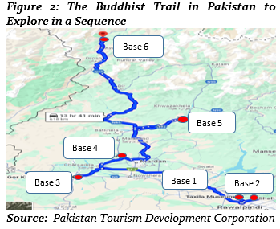

The Buddhist Trail in Pakistan, a 618 km route stretching from Taxila through Khyber Pakhtunkhwa to Swat and Chitral, is a significant cultural and historical asset. It encompasses over 150 significant Buddhist sites, including UNESCO World Heritage Sites like Taxila's ancient settlements and monasteries. This trail offers visitors access to South Asia's remarkable Buddhist heritage, making it a potential hotspot for cultural heritage tourism. Figure 2 shows the Buddhist trail in Pakistan in a sequence.
In addition to the marking on the map, below is the chart showing the cities of the Buddhist Trail with important sites and the distance to the next stop.


Buddhism is the fourth-largest religion and dominant religion in at least eight countries. Seven countries have more than fifty per cent Buddhist population, which include Cambodia (96%), Thailand (92%), Myanmar (79.8%), Bhutan (75%), Sri Lanka (70%), Laos (66.8%) and Mongolia (53%). According to a Gallup survey 2016, around 58 million Buddhist pilgrims want to visit religious sites. Out of these 58 million, five per cent want to visit Pakistan, which is almost 2.9 million people who want to visit Pakistan. However, according to the foreign ministry, only 1500 people visit Buddhist sites in Pakistan annually.
The economic potential of these heritage sites is substantial. In 2022, the World Bank reported that Pakistan attracted US$16 billion in tourist spending, which can reach US$30 billion by 2033. It generated a revenue of US$3.7 billion in 2024, and US$5.533 billion in revenue is expected by 2029. According to Business Recorder, only these Buddhist pilgrims have the potential to generate US$900 million to US$1.3 billion annually. Figure 3 shows the annual expected revenue growth in the tourism industry in Pakistan (including religious tourism).

Expected Revenue from the Tourism Industry in Pakistan till 2028
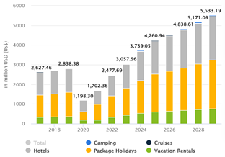

Figure 3: Tourism Outlook
Business Recorder has also claimed that Pakistan can almost double its revenue from tourism. Tourism contributes about 10% to the GDP and employs one in ten people worldwide. However, in 2022, the travel and tourism sector contributed 5.9% to Pakistan's GDP.
The restoration of damaged sites and infrastructure development are necessary to attract tourism. In this regard, the Khyber Pakhtunkhwa (KPK) Government has taken many initiatives, like the restoration of the Landi Kotal Stupa and a master plan to restore and preserve Takht-i-Bahi. The government is also working on digitally preserving these stupas and sites in 3D virtual form in collaboration with the Lahore University of Management Sciences (LUMS).
By collaborating on social media, partnering with film and television industries, and utilising virtual architecture, Pakistan can market its Buddhist heritage to attract more Buddhist tourists.
However, these efforts only preserve the heritage; its marketing to attract tourists must be further enhanced. Promoting Pakistan's religious tourism sites has remained absent from the country's social and electronic media due to content creation on more commercially viable niches generating engagement and advertising revenue.
It needs a comprehensive strategy. Uxi Mufti observes that religious tourism sites often fail to attract influencers’ attention despite their cultural and historical significance due to their perceived limited monetary potential. To attract more tourists, Pakistan needs to follow a comprehensive strategy.
  - Pakistan can leverage social media influencers from Buddhist-majority countries to promote its Buddhist heritage by collaborating with content creators in their native languages, such as Chinese influencers sharing in Mandarin clips.
  - Pakistan can also collaborate with domestic and international television and film industries by incorporating Buddhist stories and showcasing archaeological sites and present-day locations.
  - The Government needs to develop modern accommodation facilities near these sites, install multilingual signage and information boards to cater to diverse tourists and train local guides.
Pakistan can develop a comprehensive public-private partnership approach to promote Buddhist heritage tourism. By integrating government resources with private sector innovations like digital mapping, augmented reality, venture capital investments, cross-border tourism strategies, and multimedia storytelling, the country can transform historical sites into economically viable destinations that attract diverse audiences through sophisticated technological and marketing approaches.
Disclaimer: The views expressed in this Insight are of the author(s) alone and do not necessarily reflect the policy of NDU.

